Tab 1
Post 1 — Think Before You Click

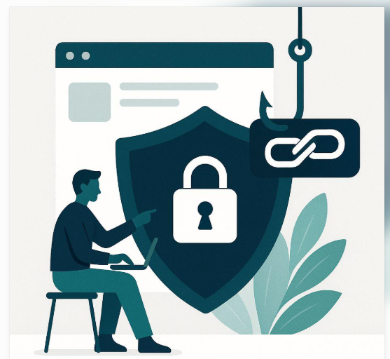
🔐 Think Before You Click!
Suspicious links and fake messages can put your personal information at risk. Check before you click, download, or share.
Stay alert. Stay safe online!
#OnlineSafety #DigitalPrivacy #StudentSafety
Post 2 — Protect Your Digital Privacy

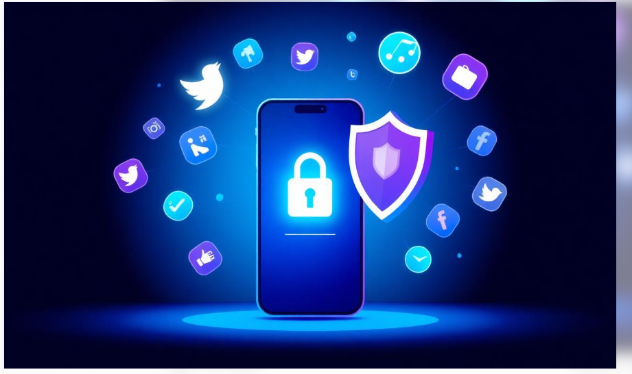
🛡️ Your Privacy Matters!
Keep your personal information safe:
- Use strong, unique passwords.
- Review your privacy settings.
- Never share verification codes.
Small habits can help protect your accounts.
#DigitalPrivacy #CyberSecurity #SafeInternet
Post 3 — Use AI Responsibly

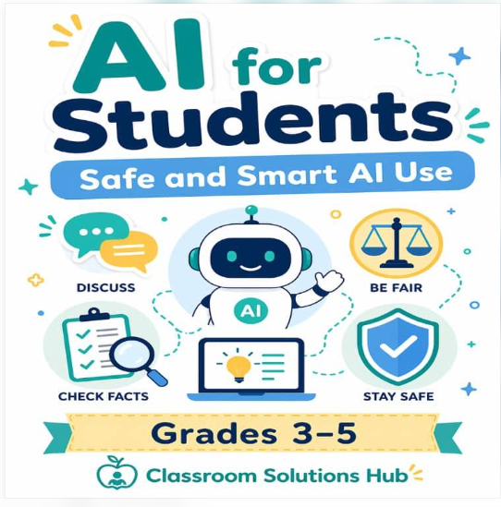

🤖 Use AI Wisely!
AI tools can support learning, but think before sharing information. Avoid entering confidential details and verify important answers with reliable sources.
Learn smart. Protect your privacy.
#ResponsibleAI #StudentLife #OnlineSafety

